- List all existing Database:
Query:

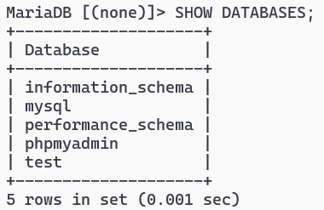
- Create a database <your-name>dbms1 i.e. Saugatdbms
Query:

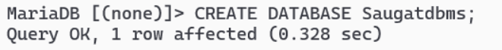
- Verify your database is created:
Query:

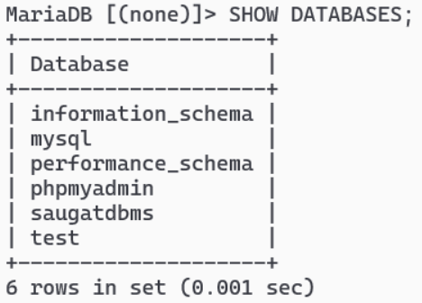

- Select your database to perform further SQL queries
Query:
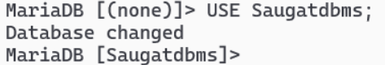
- List all Tables in database:
Query:
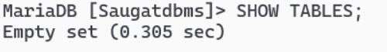
- Create tables
      - student (sid(int), name, gender, program)
Query: REATE TABLE student (sid INT, name VARCHAR(200), gender VARCHAR(200), program VARCHAR(200) );
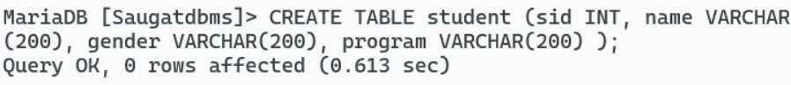

      - teacher (id(int), name, address)
Query: REATE TABLE student (sid INT, name VARCHAR(200), gender VARCHAR(200), program VARCHAR(200)
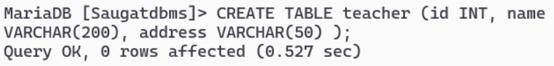
- Verify your table is created:
Query:

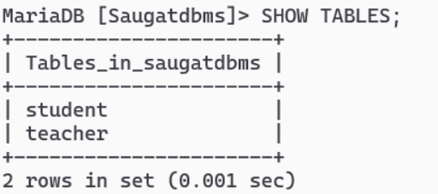
- Check properties of Tables:
Query:

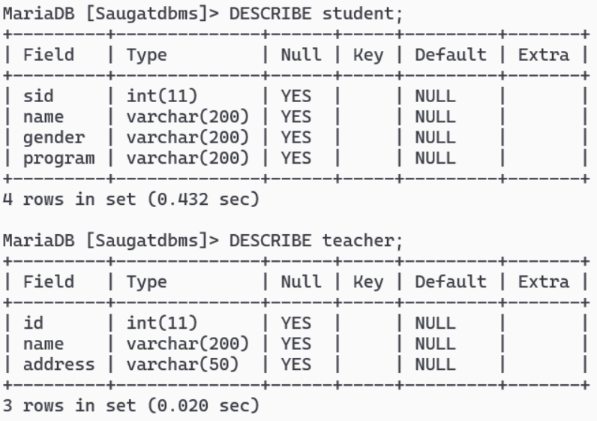
- Add a new column (contactno. varchar(20) ) in student table
Query: ALTER TABLE student ADD COLUMN contactno VARCHAR(20) NULL;
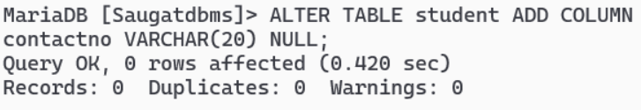
- Add a new column ( subject varchar(50) ) in teacher table.
Query: AL
TER TABLE student ADD COLUMN contactno VARCHAR(20) NULL;
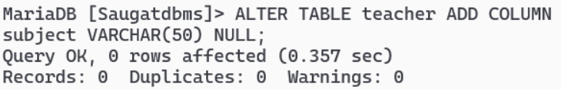

- Change column contactno of student table to int.
Query: AL
TER
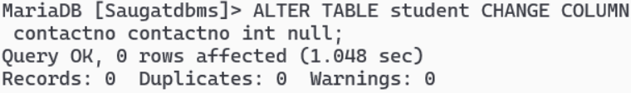null;

- Change column address of teacher table to int
Query: ALTER TABLE student CHANGE COLUMN contactno contact int null;
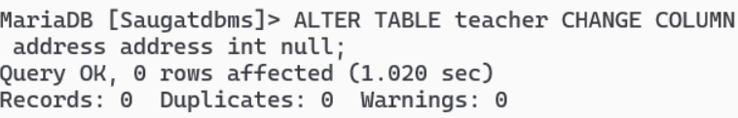

- Drop column gender from student table
Query: ALTER TA

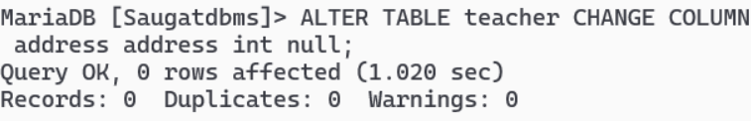

- Drop column address from teacher table
Query: ALTE
R TABLE student D
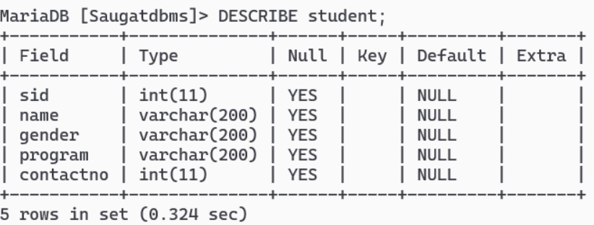
er
- Change name of name column to studentname in student table;
Query: ALTER TABLE student CHANGE COLUMN name studentname varchar(100);
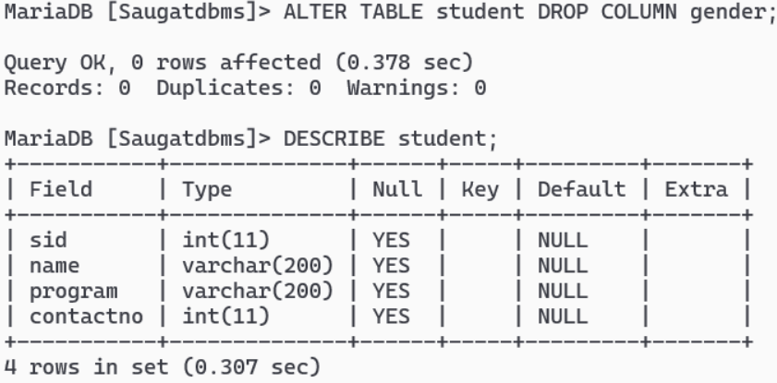

- Change name of id column to tid in teacher table;
Query: ALTER TABLE student CHANGE COLUMN name studentname varchar(100);

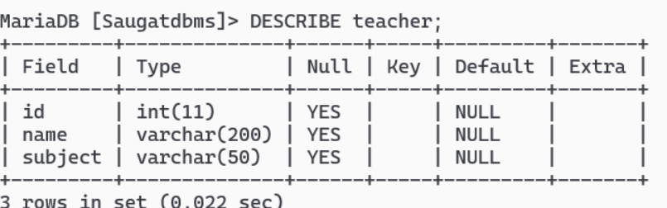

- Drop table student:
Query:

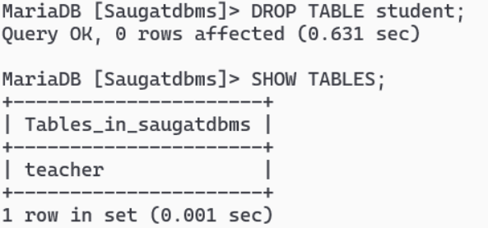

- Drop table teacher:
Query:

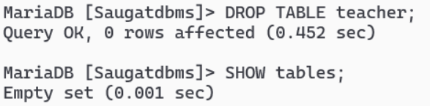

- Drop database <your-name>dbms1:
Query:

